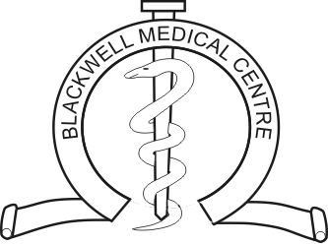
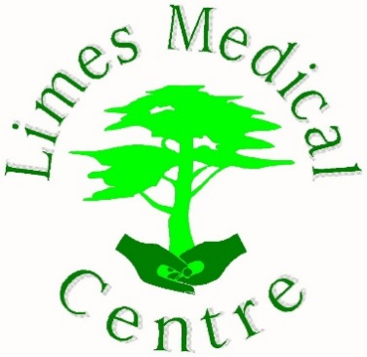

Practice merger FAQs
Limes Medical Centre & Blackwell Medical Centre are planning to merge to create a single combined patient list. The two practices will pool their management and clinical teams to offer greater resilience and a wider choice of services to all our patients. By merging both practices, we will share clinical experience and resources and patients will benefit from improved access to a wider range of clinical services and appointments.
• Why are the practices merging? In the last 5 years the pressure on single handed GPs to provide additional levels of care and services to patients has dramatically increased. This is compounded by the ongoing difficulties in GP and other clinical staff recruitment. During the last few years both practices have been working closer together to increase resilience. Both practices share the same values and ethos and believe in delivery of best medical care in a timely fashion and offering the best patient experience. The most effective way to further develop our patient services and care for our local communities is to complete a full merger.
• When will the merger take place? The merger will officially take place on the 1st April 2023, however our clinical IT systems will not merge together until the 11th April.
• Will I need to re-register to become a patient on the combined patient list? What will happen to my health records? No, you will not need to re-register, and we also anticipate that you will still be registered with the same named GP. All the patients from Blackwell Medical Centre will be automatically merged into a single combined patient list at Limes Medical Centre. All paper medical records for the combined pooled list will be held at the site the patient is registered with or registers with in future. For example, if a patient lives in Alfreton and hands in their registration forms into Limes Medical Centre, their paper record will be held there once we receive it.
• Will I have to go to another GP practice site for consultations or treatment? You will not have to go to another GP practice site if you do not wish to. However, you will be offered the choice of attending either site depending on appointment availability. You may wish to attend the site further away from you though if there is an appointment date or time more suitable to you.
• Will this mean that one of the sites will close? No. Both sites will remain open.
• Will there be a name change for my surgery No, both practices’ names will stay as they currently. The only difference is Limes Medical Centre will be the ‘main’ site and Blackwell Medical Centre will be a ‘branch’ site
• Will surgery telephone numbers change? The telephone numbers will remain the same for both sites. You will be able to contact either Limes Medical Centre or Blackwell medical centre to book appointments or discuss any other queries you may have as both systems will be merged together. We do expect however that patients will likely contact the site nearest to them as they currently do.
• Will this make it harder to contact the surgery by telephone? No. All the administrative staff from both practices will remain the same, therefore it will not affect waiting times on the phones.
• Will I still be able to make an appointment to see my usual GP or Nurse? Yes. We very much value all the one-to-one relationships our patients have with our doctors, nurse, and other clinical staff. It is therefore expected that merging practices will further increase our ability to provide you with continuity of care and access to your usual doctor or nurse. We also expect to be able to reduce the need for locum doctors and provide you with a greater number of highly skill local doctors and nurses if your usual doctor or nurse is absent from work in the future. In the case of emergency appointments however, you may be booked in with a clinician who is not your “usual” clinician as emergency appointments are dealt with by the on call clinician for that day.
• Will there be any changes made to the way I book appointments? No. We are not anticipating any changes to the way you book appointments.
• Will I still be able to book an appointment using online access? Some appointments in future will be available to book online but the majority of appointments require triaging in some form and therefore will not be available to book online to ensure they are booked with the correct clinician for the correct amount of time.
• Will my usual surgery opening times stay the same? Yes, we are not currently anticipating any changes to our core opening times which are Monday – Friday 8:00am – 6:30pm. The ‘Branch site’ at Blackwell Medical Centre may close earlier on some days where required, however the clinical capacity will increase overall.
Additional extended access for patients will continue as normal at Limes Medical Centre and are provided outside of normal GP core hours to all our patients and patients from other surgeries within our Primary Care Network. We hope that merging will mean we are able to also offer this service at Blackwell Medical Centre.
• Will the intended merger affect any treatment or medication I am currently receiving? No. Any current treatments, medications, investigations and/or referrals will not be affected by our intentions to merge.
• Will any service that is currently offered by my usual surgery be stopped or removed? No. We do not anticipate services being removed or stopped. If anything, we anticipate that the merger will bring about a greater choice of services for patients.
• How will the new arrangement benefit GPs and Nurses at the practice? Our GPs, Nurses, Physician Associates, and other Health Support Workers will all have access to a wider pool of clinical knowledge and expertise to draw upon and will have greater opportunities to specialise in areas such as diabetes, care of the elderly and urgent access. We will also be able to provide better cover for any planned or unplanned absences which we hope will alleviate the pressures felt by remaining staff. In addition, we should be able to reduce our reliance on locum or bank staff. We anticipate that the merger would provide more opportunities for enhanced training and career development.
• Will any staff be made redundant? No. All staff from both practices will continue to be employed. All staff will be employed by Limes Medical Centre.
• Will there be any change to how I access the GP out of hours service? No. To access a GP when the practice is closed, you will continue to telephone the NHS 111 service and they will either signpost you to the most appropriate service or arrange for you to access a GP.
• Will I still be invited for my long-term condition annual review? Yes, you will be contacted to make an appointment when it is due, which is usually your birth month each year.
• Will the current arrangements that I have in place for getting my medication stay the same? Yes.
• Will the practice continue to have a Patient Participation Group? We will work with PPG members from both practices and hope to take this opportunity to form one Patient Group. We would encourage any patient who would be interested to join our Group.
• Who makes the final decision? Is it already a ‘given’ that it will go ahead? The application to merge has been approved in principle by the local ICB. As it stands the merger will go ahead as planned on the 1st April 2023.
• Will my feedback be listened to? Yes. We really value the input our patients and stakeholders can contribute to this process. We are trying to provide the best possible service to meet our patient and community needs so your views and feedback are important to us.
• Will the intended merge affect any treatment or medication I am currently receiving either at my usual surgery or any hospital? No. Any current treatments, medications, investigations and/or referrals will not be affected by our intentions to merge.
• How will you make sure there is no reduction in the quality of services that are provided? The quality of our services will continue to remain our number one priority and will continue to be monitored in the same way as they are now. We will continue to benchmark all our services against both national and local targets to ensure that we are flexible in our response to meet our patients’ needs.
If I have further questions I would like to ask or comments to make, how do I do this?
You can complete a patient survey and take part in our virtual and online meetings, which will be confirmed in the coming weeks and months.
We value your opinions and would be grateful if you could spare a couple of minutes to complete our survey.

